Superconducting Quantum Processor

## A SEMINAR REPORT

*Submitted by*

## Antony S Chirayil

## MBT17CS023

*In partial fulfilment of the requirements for the award of the degree of*

## BACHELOR OF TECHNOLOGY

***in***

## COMPUTER SCIENCE AND ENGINEERING

**Of the A.P. J. Abdul Kalam Technological University**



**DEPARTMENT OF COMPUTER SCIENCE AND ENGINEERING MAR BASELIOS COLLEGE OF ENGINEERING AND TECHNOLOGY**

**MAR IVANIOS VIDYANAGAR, NALANCHIRA THIRUVANANTHAPURAM – 695 015 November 2020**

**Mar Baselios College of Engineering & Technology**

# Mar Ivanious Vidyanagar, Nalanchira, Thiruvananthapuram - 695 015

## (Affiliated to A. P. J. Abdul Kalam Technological University)

**Department of Computer Science and Engineering**



**CERTIFICATE**

This is to certify that the Seminar Report titled ‘*Superconducting Quantum Processor*’ is a bonafide record of seminar presented by Antony S Chirayil (MBT17CS023).

## Mrs. Gayathri KS Mr. Praveen G L Dr. Tessy Mathew

Seminar Co-ordinator Seminar Guide Head of the Department

***Place: Thiruvananthapuram Date: 18th September 2020***

# ACKNOWLEDGEMET

First and foremost, I thank God Almighty for His divine grace and blessings in making all these possible. May He continue to lead us in the years. It is to render my heartfelt thanks and gratitude to our principal**, Dr. T. M. George** for providing the opportunity to do this seminar during the 7th semester (2020) of my B. Tech degree course.

I am deeply thankful for our Head of the Department**, Dr. Tessy Mathew** for her support and encouragement. I would like to take this opportunity to extend my sincere gratitude to **Mr. Praveen GL** for guiding me through the process of this seminar. I would also like to thank the seminar coordinator, **Mrs. Gayathri KS**, for providing me with this opportunity which has allowed me to explore a modern technology which would otherwise be beyond the confines of my academic course.

## Antony S Chirayil

**CONTENTS**

1. INTRODUCTION 7
2. HISTORY 8
3. TECHNOLOGIES FOR IMPLEMENTING QUANTUM COMPUTING 9-10
4. SUPERCONDUCING QUBITS 11 - 12
5. TRANSMON QUBIT 13-14
6. QUANTUM LOGIC GATES 15-18
   1. Single Qubit Control Gates 16
   2. Two Qubit Control Gate 17
   3. Three Qubit Control Gate 18
7. QUANTUM PROCESSING UNIT 19
8. SUPERCONDUCING QUANTUM CIRCUIT 20-22
9. DILUTION REFRIGERATOR 23
10. D-WAVE 2000Q 24-26
11. APPLICATIONS OF QUANTUM COMPUTER 27
12. CONCLUSION 28
13. REFERENCE 29

**List of Figures**

Figure 4.1 - Superconducting qubit circuit diagram 12

Figure 5.1 - Schematic of a Transmon qubit and its effective circuit 13

Figure 5.2 - Xmon qubit 13

Figure 6.1 - Bloch Sphere 16

Figure 6.2 - Cross Resonance Interaction 17

Figure 6.3 - Gate symbol and Matrix 18

Figure 7.1 - Quantum Processing Unit 19

Figure 8.1 - Superconducting Qubit and Connection 20

Figure 8.2 - Frequency Collision Conditions 21

Figure 8.3 - The measurement results for |0⟩ or |1⟩ state 22

Figure 9.1 - Dilution Refrigerator working 23

**Abstract**

*“Quantum computing” is one of the phrases that invoke the imagination of future technology. Superconducting Quantum Processors are considered to be one of the most promising candidate technology to implement quantum computing. Due to the rapid development of superconducting quantum computing, the global race to quantum computer is in full swing. Many technology industries including Google, IBM, Microsoft as well as Intel, are jockeying for a position in quantum computing. All these advances and efforts have brought a promising future for quantum computing. In this seminar, a brief idea about fundamental concepts of superconducting quantum computing and its processor will be introduced in focus to its architecture. The quantum computing systems helps to tackle complex computations for business and financial modelling, medical researches, machine learning, communication, cryptography and engineering services. Quantum computers can solve problems that are impossible or would take a traditional computer an impractical amount of time to solve. Hence, quantum computers will change the world, leads to a better and faster solutions for the most challenging problems and so for the unprecedented applications.*

# INTRODUCTION

Quantum computers are completely new and an entirely different kind of computer quantum mechanics refers to the behavior of the most basic parts of our world. The fundamental elementary particles that make up the universe do not act in the same way the world around us does they have totally different properties, sometimes the particles can react in totally unpredictable ways even popping in and out of existence. If we take these properties out of the quantum world and enlarge them to work in our classical world, we can take advantage of them. Conventional computers work through transistors which are in two different states on or off 1 or 0 these numbers are known as binary digits or bits. These transistors react from input and the output goes through logic gates until the final result is displayed. Quantum computers work by taking the properties of quantum mechanics and applying them to computers instead of using a transistor. To compute data quantum computers, use quantum objects as a special kind of transistor, known as a quantum binary digit or qubit. The quantum object behaves in the laws of quantum mechanics, this is the reason why quantum computers are so different compared to classical computers. It competes using the special and strange properties of the quantum world, the first strange property of quantum mechanics is superposition. Superposition is a quantum phenomenon in which an object is in more than one state at once.

The real purpose of quantum computers comes in the increase in computing power with one regular bit we have two possible states or when we have two regular bits there are four possible states and the computer only outputs one of those variants. For a n qubit quantum computer there are 2n states and for multiple qubits, the states increase exponentially. This means even a simple quantum computer can be more powerful than our current supercomputers. A quantum computer can compute many different things at once but only one of those things can be displayed this means the computer will choose the best variant output. Superposition is only one of the many strange properties of quantum mechanics, one of the more bizarre parts in the quantum world is entanglement. Entanglement is a property where two particles they have exactly the opposite if two particles are entangled and one it's changed in some way the other will react the exact opposite way.

The problem with quantum computing lies in engineering. It is all about taking the microscopic world and getting it to control our macroscopic world with the microscopic world which is very hard to control and it is almost impossible to predict but if we can harness power the quantum world quantum computers will truly change the future allowing us to do things that would never be possible with classical computers. The strange properties of these special computers will open up a whole new world of computing quantum computers are very subtle and very complex machines and we still have a lot to learn about them.

# HISTORY

**1982 – Richard Feynman**: If there was one man who managed to excel at physics, to have incredible intuition along with great mathematical skill, and on top of all that be an excellent teacher and communicator, that was Richard P. Feynman. His scientific legacy includes revolutionary contributions to quantum field theory and electrodynamics, inventing the widely used Feynman diagrams, or the theory of super-fluid Helium. He was truly one of the greatest physicists of the post-WW2 era. One of his contributions, which often get overlooked, was to the first steps of quantum computing. He talked about why physicists need computers, and proposed the idea of creating machines based on the laws of quantum mechanics instead of the laws of classical physics.

**1985 - David Elieser Deutsch** is a British physicist at the [University of Oxford](https://en.wikipedia.org/wiki/University_of_Oxford). He is a visiting Professor in the Department of Atomic and Laser Physics at the [Centre for Quantum Computation](https://en.wikipedia.org/wiki/Centre_for_Quantum_Computation) in the [Clarendon Laboratory](https://en.wikipedia.org/wiki/Clarendon_Laboratory) of the University of Oxford. He pioneered the field of [quantum computation](https://en.wikipedia.org/wiki/Quantum_computation) by formulating a description for a [quantum Turing machine](https://en.wikipedia.org/wiki/Quantum_Turing_machine), as well as specifying an algorithm designed to run on a quantum computer. He has also proposed the use of entangled states and Bell's theorem for [quantum key distribution](https://en.wikipedia.org/wiki/Quantum_key_distribution) and is a proponent of the [many-worlds interpretation](https://en.wikipedia.org/wiki/Many-worlds_interpretation) of [quantum mechanics](https://en.wikipedia.org/wiki/Quantum_mechanics).

**1994 - Peter Williston Shor** is an American [professor](https://en.wikipedia.org/wiki/Professor) of [applied mathematics](https://en.wikipedia.org/wiki/Applied_mathematics) at [MIT](https://en.wikipedia.org/wiki/Massachusetts_Institute_of_Technology). He is known for his work on [quantum computation](https://en.wikipedia.org/wiki/Quantum_computation), in particular for devising [Shor's algorithm](https://en.wikipedia.org/wiki/Shor%27s_algorithm), an algorithm to factor very large numbers in polynomial exponentially faster than the best currently-known algorithm running on a classical computer.

**1997 - Lov Kumar Grover** is an [Indian](https://en.wikipedia.org/wiki/India)-[American](https://en.wikipedia.org/wiki/Americans) computer scientist. He is the originator of the [Grover database search algorithm](https://en.wikipedia.org/wiki/Grover%27s_algorithm) used in [quantum computing](https://en.wikipedia.org/wiki/Quantum_computing). Grover's 1996 algorithm is renowned as the second major algorithm proposed for [quantum computing](https://en.wikipedia.org/wiki/Quantum_computing) (after [Shor's 1994 algorithm](https://en.wikipedia.org/wiki/Shor%27s_algorithm)), and in 2017 was finally implemented in a scalable physical quantum system. [Grover's algorithm](https://en.wikipedia.org/wiki/Grover%27s_algorithm) has been the subject of numerous popular science articles.

**3. TECHNOLOGIES FOR IMPLEMENTING QUANTUM COMPUTING**

## Superconducting Qubits

## Superconducting qubits are solid state electrical circuits. Compared with the qubits based on other quantum systems (such as trapped ions, nuclear magnetic resonance, linear optical systems, etc.), superconducting qubits have manyadvantages. Superconducting qubits generally consist of superconducting electrodes, or islands, that are interconnected by Josephson junctions.

## Semiconductor Quantum Dots

## Quantum dots (QDs) are [semiconductor](https://en.wikipedia.org/wiki/Semiconductor) particles a few [nanometers](https://en.wikipedia.org/wiki/Nanometre) in size, having [optical](https://en.wikipedia.org/wiki/Light) and [electronic](https://en.wikipedia.org/wiki/Electron) properties that differ from larger particles due to [quantum mechanics](https://en.wikipedia.org/wiki/Quantum_mechanics). They are a central topic in [nanotechnology](https://en.wikipedia.org/wiki/Nanotechnology). When the quantum dots are illuminated by UV light, an electron in the quantum dot can be excited to a state of higher energy. In the case of a [semiconducting](https://en.wikipedia.org/wiki/Semiconductor) quantum dot, this process corresponds to the transition of an electron from the [valence band](https://en.wikipedia.org/wiki/Valence_band) to the [conductance band](https://en.wikipedia.org/wiki/Conductance_band). The excited electron can drop back into the valence band releasing its energy by the emission of light. This light emission ([photoluminescence](https://en.wikipedia.org/wiki/Photoluminescence)) is illustrated in the figure on the right. The color of that light depends on the energy difference between the [conductance band](https://en.wikipedia.org/wiki/Conductance_band) and the [valence band](https://en.wikipedia.org/wiki/Valence_band).

## Semiconductor [quantum dots](https://www.sciencedirect.com/topics/materials-science/quantum-dot) (QDs) has attracted considerable interest since a few years. To be part of photonic structures QDs are generally embedded in [thin films](https://www.sciencedirect.com/topics/materials-science/thin-films). After briefly reviewing the field of nano photonics, modeling of the electronic properties of QDs based on the effective mass approximation is presented.

## Trapped Ion

## A trapped ion quantum computer is an approach to a large-scale [quantum computer](https://en.wikipedia.org/wiki/Quantum_computer). [Ions](https://en.wikipedia.org/wiki/Ions), or charged atomic particles, can be confined and suspended in free space using [electromagnetic fields](https://en.wikipedia.org/wiki/Electromagnetic_fields). [Qubits](https://en.wikipedia.org/wiki/Qubits) are stored in stable electronic states of each ion, and [quantum information](https://en.wikipedia.org/wiki/Quantum_information) can be transferred through the collective quantized motion of the ions in a shared trap (interacting through the [Coulomb force](https://en.wikipedia.org/wiki/Coulomb_force)). [Lasers](https://en.wikipedia.org/wiki/Lasers) are applied to induce [coupling](https://en.wikipedia.org/wiki/Coupling_(physics)) between the qubit states (for single qubit operations) or coupling between the internal qubit states and the external motional states (for entanglement between qubits).

## Here we trap ions (for example, positively charged Calcium ions) with an oscillating electrical field inside a high-vacuum chamber. We laser-cooled the ions so it is close to stationary. A string of ions is formed and float between electrodes. Scientists have studied Atomic Physics for a century. We know its different energy states and how to manipulate between them. i.e., we know how to use these ions to create qubits. To manipulate and to measure the qubits, we shine lasers of different frequency and duration to the ions.

## Topological nanowire qubits- Majorana Qubits

## Majorana zero modes (MZM), or ‘Majoranas’, always come in pairs. To zeroth-order they can be viewed as “half-electrons”, and thus a Majorana pair constitutes a “full electron”, or a fermion. The ground state of a conventional superconductors consists of an even number of fermions, all paired up in Cooper pairs. A topological superconductor in addition to Cooper pairs hosts two Majoranas and thus can contain both an even and an odd number of fermions. These even and odd parities form a two-fold degenerate ground state, which can be used as the Majorana qubit states. Interestingly, measurements on one Majorana cannot provide any information on the parity of a pair of Majoranas. Also, local noise coupling to just one Majorana cannot extract information or influence the state of the qubit. This insensitivity due to absence of wave function overlap, or interactions in general, is provided by the large separation between the two “half-electrons”. This is referred to as topological protection. The resulting enhanced qubit stability is the motivation for pursuing topological quantum computation. Majorana nanowires consist out of a semiconducting wire with large spin-orbit interaction (e.g. InAs or InSb) partially covered by a conventional superconductor (e.g. A1). For appropriate electron densities and magnetic fields Majorana zero modes (MZM) appear at the two wire ends.

## Nuclear Magnetic Resonance

## Nuclear magnetic resonance quantum computing (NMRQC) is one of the several proposed approaches for constructing a [quantum computer](https://en.wikipedia.org/wiki/Quantum_computer), that uses the [spin](https://en.wikipedia.org/wiki/Spin_(physics)) states of nuclei within molecules as [qubits](https://en.wikipedia.org/wiki/Qubit). The quantum states are probed through the [nuclear magnetic resonances](https://en.wikipedia.org/wiki/Nuclear_magnetic_resonance), allowing the system to be implemented as a variation of [nuclear magnetic resonance spectroscopy](https://en.wikipedia.org/wiki/Nuclear_magnetic_resonance_spectroscopy). NMR differs from other implementations of [quantum computers](https://en.wikipedia.org/wiki/Quantum_computer) in that it uses an [ensemble](https://en.wikipedia.org/wiki/Quantum_ensemble) of systems, in this case molecules, rather than a single pure state. Initially the approach was to use the spin properties of atoms of particular molecules in a liquid sample as qubits - this is known as liquid state NMR (LSNMR). This approach has since been superseded by [solid state](https://en.wikipedia.org/wiki/Solid-state_physics) NMR (SSNMR) as a means of quantum computation

# SUPERCONDUCTING QUBITS

Superconducting qubits are solid state electrical circuits. Compared with the qubits based on other quantum systems (such as trapped ions, nuclear magnetic resonance, linear optical systems, etc.), superconducting qubits have the following advantages:

**1.High designability**

Superconducting qubit system has high designability. Different types of qubits, such as charge qubits, flux qubits, and phase qubits, can be designed. And different parameters, such as the energy level of the qubit and the coupling strength, can also be adjusted by adjusting the capacitance, inductance, and Josephson energy. Thus, the Hamiltonian of superconducting qubits can be designed.

**2.Scalability**

The preparation of superconducting qubits is based on the existing semiconductor microfabrication process. High-quality devices can be prepared by leveraging advanced chip-making technologies, which is good for manufacturing and scalability.

**3. Easy to couple**

The circuit nature of the superconducting qubit system makes it relatively easy to couple multiple qubits together. In general, superconducting qubits can be coupled by capacitance or inductance.

**4. Easy to control**

The operation and measurement of superconducting qubits compatible with microwave control and operability. Thus, commercial microwave devices and equipment can be used in superconducting quantum computing experiments. These advantages make superconducting qubits become the leading candidate for scalable quantum computing. However, to build a large-scale quantum computing, there still remain some outstanding challenges. Due to the tunability and large size of superconducting qubits, the primary disadvantage of superconducting qubits is their short coherence times.

Superconducting qubits require dilution refrigerators to maintain temperatures low enough, and advances of the capacity of such cryostats should be made before building a device with millions of qubits. In the last few years, superconducting qubits have seen drastic improvements

in coherence time, operation fidelities, fast and high-fidelity qubit readout, and even demonstrations of error correction and quantum algorithms, which we will introduce in the following contents

According to different degrees of freedom, superconducting qubits are mainly divided into three categories: charge qubits, flux qubits, and phase qubits. We can distinguish these tree types of superconducting qubit according to the ratio EJ=EC, where EJ is Josephson energy and EC is charging energy. The charge qubit is also called Cooper-pair box qubit, which is shown in Fig. 4.1(a). For the charge qubit, the electrostatic energy of the Cooper-pair on the superconducting island is much larger than the Josephson coupling energy on the junction EJ << EC. The relevant quantum variable is the number of Cooper pairs that cross Josephson junction. Fig.4.1(b) is a schematic diagram of a flux qubit. Typically, EJ/EC is much larger than 1 but smaller than 100 for flux qubit. The states of the flux qubit are distinguished by the direction of the continuous current state in the superconducting loop. As shown in Fig. 4.1(c), the phase qubit is a current-biased single-junction device with a large ratio EJ/EC (EJ >> EC). Using the two lowest energy levels of the washboard potential, one phase qubit can be encoded.

Based on the three superconducting qubit archetypes, many new types of superconducting qubits are derived, such as Transmon-type qubit, C-shunt flux qubit, Fluxonium, 0-π qubit, Hybrid qubit

FIG.4.1. Superconducting qubit circuit diagram.

 (a) Charge qubit composed of a Josephson junction and a capacitor. Adjusting the voltage Vg can control the number of Cooper pairs.

(b) Flux qubit. L is the loop inductance. Changing the bias flux _ can adjust the energy level structure of the qubit.

(c) Phase qubit. Adjusting the bias current Ib can tilt the potential energy surface.

Figure 4.1

## TRANSMON QUBIT

Transmon-type qubit, including Transmon, Xmon, Gmon, 3D Transmon etc., is currently the most popular superconducting qubit due to its simplicity and the flexibility of cQED architectures. Transmon was first proposed by Koch et al: in 2007. In the charge qubit, the charge dispersion decreases exponentially in EJ=EC, and the anharmonicity algebraically decreases with a slow power law of EJ=EC. Therefore, properly increasing EJ=EC can greatly reduce the sensitivity of the system to charges, while still maintaining sufficient anharmonicity. As shown in Fig.5.1, the charge energy of Transmon qubit are decreased by paralleling a large interdigitated capacitor across the Josephson junction, thereby obtaining EJ=EC_100.

Figure 5.1

FIG. 5.1 Schematic of a Transmon qubit and its effective circuit. (a) The effective circuit model of a Transmon qubit. CB is a large capacitor in parallel with superconducting quantum interference device (SQUID). Lr and Cr are connected in parallel to form an equivalent circuit of the readout resonator. The circuit on the far right is the flux bias of SQUID. (b) Schematic of 2D structure of a Transmon qubit.

Xmon can be considered as a modified version of Transmon, which was proposed by Barends et al: in 2013. The Xmon qubit is formed by a cross capacitor, and the Xmon qubit is coupled to a common transmission line through a resonant cavity. In fig.5.2 each Xmon is controlled by two independent control lines, a XY control line and a Z control line, which can be used for rotating the quantum state in the X, Y and Z directions. The qubits can be directly coupled through capacitance. The Xmon qubit combines fast control, long coherence, and straightforward connectivity, which is suitable for scalable superconducting quantum computing. Gmon is based on the Xmon qubit, but the qubits are connected with a junction serving as a tunable inductor to control the coupling strength (see Fig. 5.2).

FFigure 5.2

The Gmon architecture is protected from the problem of frequency crowding that arise from fixed coupling, and provides a flexible platform with applications ranging from quantum computing to quantum simulation. However, the extra inductive coupler introduces additional decoherent channels, and the device layout becomes very complicated. In 2018, Yan et al: proposed a simple and generic scheme for a tunable coupler, which is a generic three-body system in a chain geometry, and the center mode is a tunable coupler. The centre mode can be constructed with any flux-tunable circuit in which the resonance frequency can be tuned. By modulating the coupler frequency, the coupling strength of the two next-nearest neighbour qubits can be tuned. This architecture does not introduce additional components, and its layout is similar to the Xmon.

3D Transmon is a development of Transmon qubits, which was proposed by Paik et al: in 2011. The biggest feature of 3D Transmon is the replacement of the planar transmission line cavities with a three-dimensional waveguide cavity, which offers several advantages. First, the cavity has a larger mode volume and is much less sensitive to the surface dielectric losses. Second, the architecture provides the qubit with a well-controlled electromagnetic environment. Thus, this architecture could suppress the decoherence of

qubit while maintaining sufficient coupling to the control signal. However, scalability is the major difficulty we have to overcome, if we want to build a large-scale device based on 3D Transmon.

1. **QUANTUM LOGIC GATES**

In [quantum computing](https://en.wikipedia.org/wiki/Quantum_computing) and specifically the [quantum circuit](https://en.wikipedia.org/wiki/Quantum_circuit) model of computation, a quantum logic gate (or simply quantum gate) is a basic [quantum circuit](https://en.wikipedia.org/wiki/Quantum_circuit) operating on a small number of [qubits](https://en.wikipedia.org/wiki/Qubit). They are the building blocks of quantum circuits, like classical [logic gates](https://en.wikipedia.org/wiki/Logic_gate) are for conventional digital circuits. Unlike many classical logic gates, quantum logic gates are [reversible](https://en.wikipedia.org/wiki/Reversible_computing). However, it is possible to perform classical computing using only reversible gates. Quantum logic gates are represented by [unitary matrices](https://en.wikipedia.org/wiki/Unitary_matrix). The number of qubits in the input and output of the gate must be equal; a gate which acts on n n {\displaystyle n} qubits is represented by a 2n x 2n  2 n × 2 n {\displaystyle 2^{n}\times 2^{n}} unitary matrix. The quantum states that the gates act upon are vectors in 2n 2 n {\displaystyle 2^{n}}

complex dimensions. The base vectors are the possible outcomes if measured, and a quantum state is a linear combination of these outcomes. The most common quantum gates operate on spaces of one or two qubits, just like the common classical [logic gates](https://en.wikipedia.org/wiki/Logic_gate) operate on one or two bits. Quantum states are typically represented by "kets", from a mathematical notation known as [bra-ket](https://en.wikipedia.org/wiki/Bra%E2%80%93ket_notation). The vector representation of a single qubit is:

Here, $ϑ_{0}$ and $ϑ_{1}$ are the complex probability amplitudes of the qubit. These values determine the probability of measuring a 0 or a 1, when measuring the state of the qubit. See measurement below for details. The value zero is represented by the ket | 0 ⟩ = [1 0] and the value one is represented by the ket | 1 ⟩ = [ 0 1 ]

The tensor product is used to combine quantum states. The combined state of two qubits is the tensor product of the two qubits. The tensor product is denoted by the symbol ⊗

The vector representation of two qubits is:

1. **Single Qubit Control Gates**

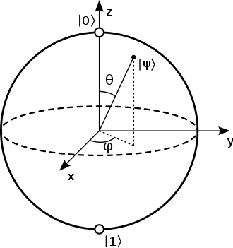

The Bloch sphere is a unit 2-sphere. The north and south poles of the Bloch sphere are typically chosen to correspond to the standard basis vectors |0⟩ and |1⟩ respectively, which in turn might correspond e.g. to the *spin-up* and spin-down states of an electron. This choice is arbitrary, however. The points on the surface of the sphere correspond to the pure states of the system, whereas the interior points correspond to the mixed states.See fig.6.1.

In accordance with Bloch sphere: Figure 6.1

### **Hadamard (H) gate**

The Hadamard gate acts on a single qubit. It maps the basis state |0⟩ | 0 ⟩ {\displaystyle |0\rangle } to |0⟩ + |1⟩ /√2 | 0 ⟩ + | 1 ⟩ 2 {\displaystyle {\frac {|0\rangle +|1\rangle }{\sqrt {2}}}} and ||1⟩ 1 ⟩ {\displaystyle |1\rangle } to | 0 ⟩ − | 1 ⟩ 2 {\displaystyle {\frac {|0\rangle -|1\rangle }{\sqrt {2}}}} |0⟩-|1⟩/√2, which means that a measurement will have equal probabilities to become 1 or 0 (i.e. creates a [superposition](https://en.wikipedia.org/wiki/Quantum_superposition)). It represents a rotation of ππ {\displaystyle \pi } about the axis (x + z) /√2 ( x ^ + z ^ ) / 2 {\displaystyle ({\hat {x}}+{\hat {z}})/{\sqrt {2}}}x+xat the [Bloch sphere](https://en.wikipedia.org/wiki/Bloch_sphere). Equivalently, it is the combination of two rotations, π/2 π / 2 {\displaystyle \pi /2} pi pxabout the Y-axis, then by π π {\displaystyle \pi } fsdsf\about the Z-axis: Ry(π/2 )Rz(π) = iHR y ( π / 2 ) R z ( π ) = i H {\displaystyle R_{y}(\pi /2)R_{z}(\pi )=iH}. It is represented by the [Hadamard matrix](https://en.wikipedia.org/wiki/Hadamard_matrix) given in fig 6.3

**Pauli-X gate**

The Pauli-X gate acts on a single qubit. It is the quantum equivalent of the NOT gate for classical computers (with respect to the standard basis |0⟩, |1⟩ which distinguishes the Z-direction; in the sense that a measurement of the eigenvalue +1 corresponds to classical 1/true and -1 to 0/false). It equates to a rotation around the X-axis of the Bloch sphere by π radians. It maps |0⟩ to |1⟩ and |1⟩to |0⟩.Due to this nature, it is sometimes called [bit-flip](https://quantumexperience.ng.bluemix.net/qx/tutorial?sectionId=beginners-guide&page=005-Single-Qubit_Gates~2F006-Summary_of_quantum_gates).

### **Pauli-Y gate**

### The Pauli-Y gate acts on a single qubit. It equates to a rotation around the Y-axis of the [Bloch sphere](https://en.wikipedia.org/wiki/Bloch_sphere) by π π {\displaystyle \pi } radians. It maps |0⟩ to i|1⟩ and |1⟩to -i|0⟩.

### **Pauli-Z gate**

The Pauli-Z gate acts on a single qubit. It equates to a rotation around the Z-axis of the [Bloch sphere](https://en.wikipedia.org/wiki/Bloch_sphere) by π π {\displaystyle \pi } radians. It leaves the basis state |0⟩ unchanged and maps |1⟩to -|1⟩. Due to this nature, it is sometimes called phase-flip

### **Square root of NOT gate**

The square root of NOT gate (or square root of Pauli-X) acts on a single qubit. Squared root-gates can be constructed for all other gates by finding a unitary matrix that, multiplied by itself, yields the gate one wishes to construct the squared root gate of. All rational exponents of all gates can be found similarly.

1. **Two Qubit Control Gate**

### **Swap (SWAP) gate**

The swap gate swaps two qubits. With respect to the basis |00⟩, |01⟩, |10⟩, |11⟩. It is represented in the figure.

### **Square root of Swap gate $(\sqrt{SWAP})$**

The $\sqrt{SWAP}$ gate performs half-way of a two-qubit swap. It is universal such that any many-qubit gate can be constructed from only $\sqrt{SWAP}$ and single qubit gates. The SWAP SWAPgate is not, however maximally entangling; more than one application of it is required to produce a Bell state from product states.

### **Controlled (cX cY cZ) gates**

Controlled gates act on 2 or more qubits, where one or more qubits act as a control for some operation. For example, the [controlled NOT gate](https://en.wikipedia.org/wiki/Controlled_NOT_gate) (or CNOT or cX) acts on 2 qubits, and performs the NOT operation on the second qubit only when the first qubit is |1⟩ , and otherwise leaves it unchanged. With respect to the basis | 00 ⟩ {\displaystyle |00\rangle }|00⟩, |01⟩, |10⟩, |11⟩ figure representation

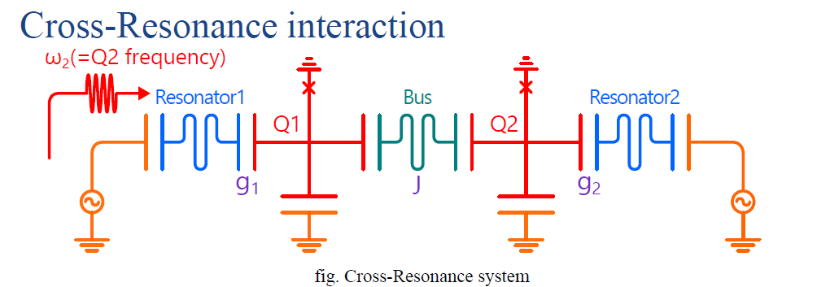**Cross-resonance gate**

Figure – 6.2

The cross-resonance gate is an entangling gate for fixed frequency superconducting qubits, which is implemented by applying a microwave drive to a system of two coupled qubits as showed Fig. The cross-resonance gate was first implemented in 2011 and they used quantum process tomography (QPT) to reveal a gate fidelity of 81%. Corcoles et al: presented a complete RB characterization of two fixed-frequency superconducting qubits, and achieved a gate fidelity of 93.47% under interleaved RB experiment which compares favourably to the fidelity of 87.99% obtained by QPT performed on the same gate. Sheldon et al: presented improvements implementation of the cross-resonance gate with shorter gate time (160 ns) and interleaved RB fidelities exceeding 99%.

1. **Three Qubit Control Gate**

### **Toffoli (CCNOT) gate**

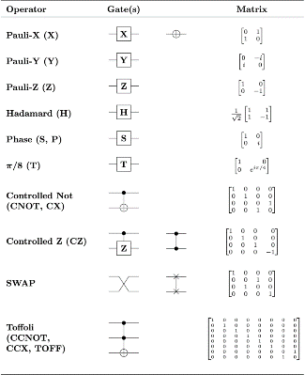The Toffoli gate, named after [Tommaso Toffoli](https://en.wikipedia.org/wiki/Tommaso_Toffoli); also called CCNOT gate or Deutsch gate; is a 3-bit gate, which is [universal](https://en.wikipedia.org/wiki/Functional_completeness) for classical computation but not for quantum computation. The quantum Toffoli gate is the same gate, defined for 3 qubits. If we limit ourselves to only accepting input qubits that are |0⟩ and |1⟩ then if the first two bits are in the state |1⟩ it applies a Pauli-X (or NOT) on the third bit, else it does nothing. It is an example of a controlled gate. Since it is the quantum analog of a classical gate, it is completely specified by its truth table. The Toffoli gate is universal when combined with the single qubit Hadamard gate.

### **Fredkin (CSWAP) gate**

The Fredkin gate (also CSWAP or cS gate), named after [Edward Fredkin](https://en.wikipedia.org/wiki/Edward_Fredkin), is a 3-bit gate that performs a [controlled](https://en.wikipedia.org/wiki/Quantum_gate#Controlled_gates) [swap](https://en.wikipedia.org/wiki/Quantum_gate#Swap_gate). It is [universal](https://en.wikipedia.org/wiki/Functional_completeness) for classical computation. It has the useful property that the numbers of 0s and 1s are conserved throughout, which in the [billiard ball model](https://en.wikipedia.org/wiki/Billiard-ball_computer) means the same number of balls are output as input. Figure 6.3

1. **QUANTUM PROCESSING UNIT**

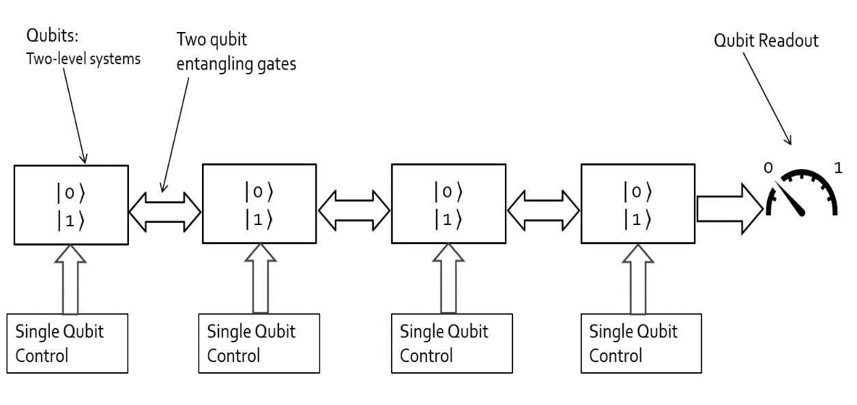

Figure 7.1

Quantum circuit is a model of QC in which the computation is a sequence of quantum gates and measurement operations. The state of the qubits is first initialized and then manipulated by a sequence of operations. Single-qubit gates and measurement operations are applied on individual qubits while two-qubit gates are applied on two logical qubits. It has been proved that any multi-qubit

gate can be decomposed into a series of single-qubit gates and CNOT gates (a specific two-qubit gate).

Here we are discussing about quantum information processing and eventually building a quantum processor. We need qubits and quantum systems like two level quantum systems and we need to control these qubits using single qubit control gates. It requires a lot of qubits to increase the processing capabilities, when using more qubits, we need them to interact with each other so we use two qubit gates and finally we need to readout the information processed from the qubits, which are 0s and 1's for that we use qubit readout. This has many challenges first we have to have use gates which are super-fast readout part should be super-efficient with less error rate and more fidelity and should be strongly coupled to other qubits and the qubits should have long coherence i.e. the 0's and 1's should be sharp and have stay for long time

1. **SUPERCONDUCING QUANTUM CIRCUIT**

All the qubits and quantum operations in a quantum circuit must be implemented in a real physical QC system to execute the program. Superconducting quantum processors with fixed-frequency Josephson junction- based transmon qubits and all-microwave cross resonance two-qubit gates adopted by IBM.

For designing a quantum circuit we have to understand the following:

**Physical Qubit and Frequency**

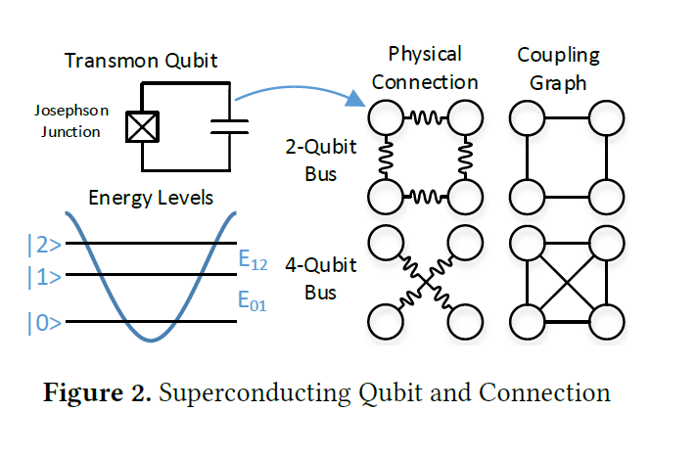 Figure 8.1 shows the physical circuit and energy levels of a transmon qubit. Due to the nonlinearity of the Josephson junction, the gaps between the energy levels in this quantum anharmonic oscillator are different, which allows us to use the ground state |0 > and the first-excited state |1>as the computation basis without populating other states. Suppose the energy gap between |0> and |1> for a qubit is E01. The frequency of this qubit f01 is defined as f01 = E01/h, where h is the Planck constant. Similarly, we use f12 to represent the energy gap between |1> and |2>.For a typical qubit design with effective operations, f01 and f12 are about 5GHz and 4.66 GHz, respectively. The anharmonicity of this qubit is defined to be SIGMA = f12 – f 01 which is −340MHz under this typical design.

Figure 8.1

**Qubit Layout**

The superconducting physical qubits are confined on a 2-dimensional planar substrate. Although the

qubit placement can be flexible, major vendors fabricate the qubits in a regularized structure to ensure scalability and reduce the fabrication complexity. For example, IBM’s 16- qubit and 20-qubit chips placed their qubits on the nodes of 2x8 and 4x5 lattices, respectively. Google’s 72-qubit chip placed its qubits on some nodes of an 11 x 12 lattice

**Qubit Connection**

To enable two-qubit gates between two physical qubits, resonators, also known as qubit buses, are employed to connect nearby qubits. For example, Figure 8.1 shows two types of commonly used buses. The first one is a 2-qubit bus connecting two physical qubits. The second one is a 4-qubit bus, which connects four physical qubits in a square together. The coupling graphs of these two types of buses are shown on the right. Compared with a 2-qubit bus, 4-qubit bus support two-qubit gates on not only

the four qubit pairs on the edges but also two qubit pairs on the diagonals

**Qubit Mapping**

It is usually assumed that a two-qubit gate can be applied on arbitrary two logical qubits in a quantum program but some two-qubit gates may not be executable due to the limited qubit connection on a superconducting quantum processor. On the hardware side, this problem can be relieved by employing more physical qubit connections so that two-qubit gates can be directly supported on more qubit pairs. On the software side, a qubit-remapping compiler can resolve the dependency of the remaining inexecutable two-qubit gates while additional operations must be introduced with longer execution time and higher error rate. Therefore, more physical qubit connections can help with the overall performance by allowing native two-qubit gates on more physical qubit pairs.

**Fabrication Variation**

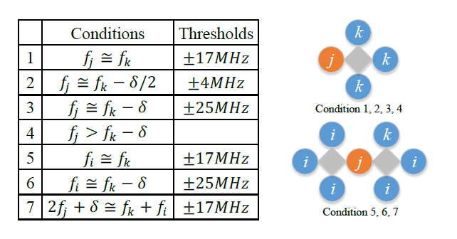Variation is inevitable when fabricating a superconducting quantum processor. If a qubit is designed to have frequency f, the actual frequency after fabrication will be f’=f + nf, where nf where nf satisfies Gaussian satisfies Gaussian distribution N (0, σ). σ is the fabrication precision parameter, which is around 130MHz ⇠ 150MHz under IBM’s state-of-the-art technology. Such noise makes it hard to predict the post-fabrication frequency precisely, which brings the probability of frequency collision.

Figure 8.2

**Frequency Collision**

When two or three qubits are connected, frequency collision may happen and cause defects on the device. Figure ----- summaries seven qubit frequency collision conditions in IBM’s devices. On the left is a table showing the conditions and thresholds of different collision situations. Condition 1, 2, 3, and 4 involve two connected qubits (j and k). Condition 5, 6, and 7 involve three qubits of which two qubits (k and i) both connect to the other qubit j. The approximate equations and the corresponding thresholds

determine whether one frequency collision happens. For example, if qubit j and k are connected and |fj−fk| < 17MHz, then the first condition is satisfied and frequency collision occur. Note that the fourth condition has no threshold because it is an inequality rather than an approximate equation. On the right is a graphical illustration, showing the geometric locations of the qubits that may have frequency collisions of different conditions in two subfigures. Each circle represents one qubit and the grey square represent a 4-qubit bus connecting the four surrounding qubits.

**Qubit Readout**

Fast and high-fidelity qubit readout is crucial in quantum computing. Historically, there are several different readout techniques for superconducting qubit, such as charge measurement, flux measurement, inductance measurement, etc. The dispersive readout is the currently most common readout technique in the circuit QED architecture, which we will briefly introduce in this section. In addition, the techniques to improve the fidelity and speed of qubit readout is introduced here:

**1.High-fidelity single-shot readout**:

To achieve fast, high-fidelity single shot readout, Purcell filter and parametric amplifier are typical tools for superconducting quantum computing. Various types are:

* Purcell Filter
* Josephson parametric amplifier (JPA)
* Impedance-transformed parametric amplifier (IMPA)
* Traveling wave parametric amplifier (TWPA)



**2.Dispersive readout**

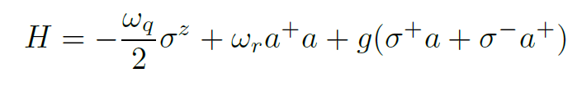It is to obtain the qubit state information through the readout resonator. The qubit circuit is coupled to the readout resonator through capacitance or inductance, and the state of the qubit is detected by measuring the transmission coefficient of the readout resonator. During the measurement, the qubit and the readout resonator form the Hamiltonian of the Jaynes-Cummings model

Figure 8.3

The state of the qubit affects the frequency of the readout resonator, and the change in the frequency of the readout resonator will be reflected in the measurement of the transmission coefficient. A microwave with a specific frequency and length is input on a transmission line coupled to the readout resonator. After capturing the signal coming from the end of the transmission line and integrating the signal, we could get a point (I + iQ) in the complex plane. We can find that the measurement results of states |0⟩ and |1⟩ are clustered in two distinguishable clusters, respectively (see Fig.8.3). The dispersive readout provides a feasible way for the quantum non-demolition (QND) readout of superconducting quantum computing.

1. **DILUTION REFRIGERATOR**

Maintaining an extremely low temperature is important in a superconducting quantum computer, for this purpose we use dilution refrigeration. This dilution refrigerator has a system of pipes that contain a mixture of two helium isotopes (isotope ③ and ④). As the lighter isotope ③ is **diluted** into the heavier isotopes ④ inside the mixing chamber below, it absorbs heat as the entropy increases, a mixed solution is more disorder and has higher entropy. So, the temperature surrounding the mixing chamber will drop. The mixing chamber is connected to the upper distilling chamber. Since isotopes ③ has a higher boiling point, it will vaporize. This reduces the concentration of isotopes ③ and draws more isotopes ③ to be diluted into the mixture in the other end, i.e. inside the mixing chamber. So, the cooling process creates a cycling circle.

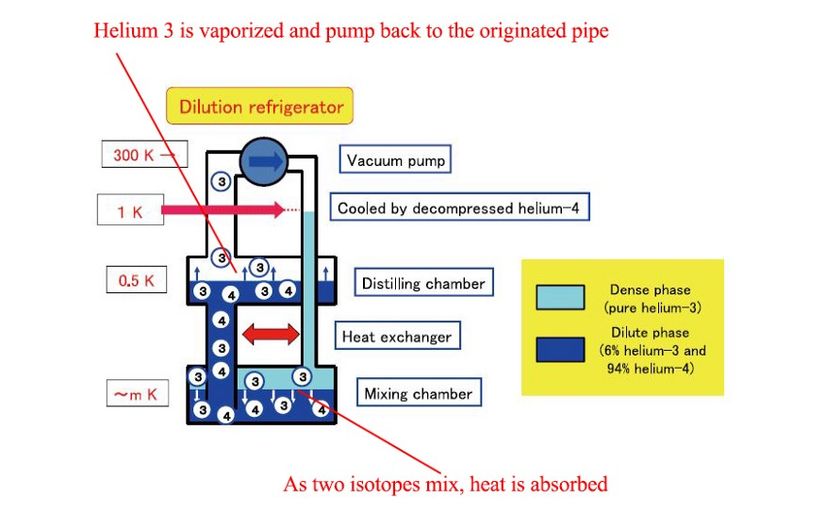

Figure 9.1

For Example, the IBM Q’s dilution refrigerator cools temperature from 4**°** Kelvin to 15 Millikelvins at the Cryoperm shield (this shield hosts the quantum processor). The cables are used to send microwave pulses down to the processor and it reads out measurements using the amplifier. The quantum processor sits inside the Cryoperm shield which is a light-tight and a magnetic-field shield, used to isolate the qubits from environmental disturbances.

1. **D-WAVE 2000Q**

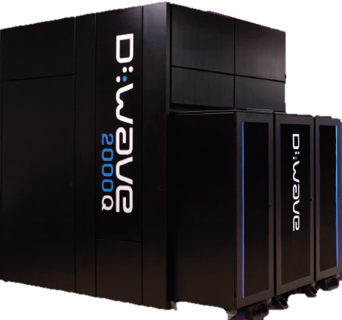

Despite the incredible power of today’s supercomputers, many complex computing problems cannot be addressed by conventional systems. The huge growth of data and our need to better understand everything from the universe to our own DNA leads us to seek new tools that can help provide answers. Quantum computing is the next frontier in computing, providing an entirely new approach to solving the world’s most difficult challenges. D-Wave Systems is the leader in the development and delivery of quantum computing systems and software, and the world’s only commercial supplier of quantum computers. Our mission is to unlock the power of quantum computing for the world. We believe that quantum computing will enable solutions to the most challenging national defence, scientific, technical, and commercial problems.

These systems are being used by some of the world’s most advanced organizations, including Lockheed Martin, Google, NASA Ames, the University of Southern California, and Los Alamos National Laboratory. The D-Wave 2000Q™ quantum computer leverages quantum dynamics to accelerate and enable new methods for solving discrete optimization, sampling, and machine learning problems. D-Wave systems use a process called quantum annealingto search for solutions to a problem. Quantum annealing is fundamentally different from classical computing. It harnesses the natural tendency of real-world quantum systems to find low-energy states. If an optimization problem is analogous to a landscape of peaks and valleys, for instance, each coordinate represents a possible solution and its elevation represents its energy. The best solution is that with the lowest energy corresponding to the lowest point in the deepest valley in the landscape. Computation is performed by initializing the quantum processing unit (QPU) into a ground state of a known problem and annealing the system toward the problem to be solved such that it remains in a low energy state throughout the process. At the end of the computation, each qubit ends up as either a 0 or 1. This final state is the optimal or near-optimal solution to the problem to be solved.

The D-Wave 2000Q system has a footprint of approximately 10' x 7' x 10' (L x W x H). Its physical enclosure houses sophisticated cryogenic refrigeration, shielding, and I/O systems to support a single thumbnail-sized QPU. Most of the physical volume of the system is required to accommodate the refrigeration system and to provide easy service access. For quantum effects to play a role in computation, the QPU requires an extreme, isolated environment. The refrigerator and layers of shielding create an internal high vacuum environment with a temperature close to absolute zero that is isolated from external magnetic fields, vibration, and RF signals of any form. Adjoining cabinets contain the control subsystems and the front-end servers that provide connectivity to the system

The D-Wave 2000Q system operates near absolute zero. This extremely low temperature, along with the shielded environment that isolates the QPU from its surroundings, enables the QPU to behave quantum mechanically. D-Wave systems operate at less than 15 millikelvin, approximately 180 times colder than interstellar space. D-Wave’s “dry” dilution refrigerator uses liquid helium refrigerant in a closed-loop system, avoiding the need for on-site replenishment.

While dilution refrigerators are not uncommon in research environments, D-Wave has advanced the technology to ensure long run-life and reliability in a commercial product setting. Despite the extreme environment inside the system, a standard data center can normally accommodate the D-Wave 2000Q quantum computer.

**I/O, Shielding, and Materials**

The extreme isolated environment required for the QPU places unusual demands on the design, materials, and manufacturing processes required for the various subsystems.

The I/O subsystem that passes information to the QPU and back while filtering out all unwanted noise requires a variety of normal and superconducting materials to provide the required performance. The magnetic shielding subsystem provides the low-field environment required for the QPU, using high-permeability and superconducting materials to achieve fields below 1 nanotesla. This is 50,000 times less than the Earth’s magnetic field.

**Quantum Processing Unit**

The D-Wave QPU is built from a lattice of tiny loops of the metal niobium, each of which is one qubit (shown on the next page, in red). Below temperatures of 9.2 kelvin, niobium becomes a superconductor and exhibits quantum mechanical effects. When in a quantum state, current flows in both directions simultaneously, which means that the qubit is in superposition—that is, in both a 0 and a 1 state at the same time. At the end of the problem-solving process, this superposition collapses into one of the two classical states, 0 or 1.

Going from a single qubit to a multi-qubit QPU requires that the qubits be interconnected to exchange information. Qubits are connected via couplers, which are also superconducting loops. The interconnection of qubits and couplers, together with control circuitry to manage the magnetic fields, creates an integrated fabric of programmable quantum devices.

When the QPU arrives at a solution to a problem, all qubits settle into their final states and the values they hold are returned to the user as a bit string. The D-Wave 2000Q system has up to 2048 qubits and 5600 couplers. To reach this scale, it uses 128,000 Josephson junctions, which makes the D-Wave 2000Q QPU by far the most complex superconducting integrated circuit ever built.

**Energy Efficiency**

Unlike the CPUs of classical computers, D-Wave’s superconducting QPU dissipates negligible amounts of heat during computation. While traditional supercomputers generate massive amounts of heat and consume massive amounts of power, the D-Wave system consumes less than 25 kW of power, most of which goes towards operating the cooling and front-end servers. This low power consumption has remained constant since the introduction of the first D-Wave system despite the dramatic increase in system performance with each successive product generation.

1. **APPLICATIONS OF QUANTUM COMPUTER**

Machine Learning & Artificial Intelligence

Used to Detecting statistical anomalies and for finding compressed models Recognizing images and patterns.

It can be used for Training neural networks. Classifying unstructured data is made easy with the help of quantum computer and complicated circuit faults can be diagnosed using QC. As the number of applications increased, it becomes a challenging task for traditional computers, to match up the accuracy and speed. And, that’s where quantum computing can help in processing through complex problems in very less time, which would have taken traditional computers thousands of years.

**Financial Modelling**

1. Various market instabilities can be determined. They are used for developing trading strategies and for optimizing trading trajectories and patterns. by applying quantum technology to perform massive and complex calculations, companies can not only improve the quality of the solutions but also reduce the time to develop them. Because financial leaders are in a business of handling billions of dollars, even a tiny improvement in the expected return can be worth a lot for them. Algorithmic trading is another potential application where the machine uses complex algorithms to automatically trigger share dealings analyzing the market variables, which is an advantage, especially for high-volume transactions.

**Security**

1. Detecting computer viruses & network intrusion and Scheduling resources and optimal paths can be done using a QC. The online security space currently has been quite vulnerable due to the increasing number of cyber-attacks occurring across the globe, on a daily basis. Although companies are establishing necessary security framework in their organizations, the process becomes daunting and impractical for classical digital computers. And, therefore, cybersecurity has continued to be an essential concern around the world. With our increasing dependency on digitization, we are becoming even more vulnerable to these threats. Quantum computing with the help of machine learning can help in developing various techniques to combat these cybersecurity threats. Additionally, quantum computing can help in creating encryption methods, also known as, quantum cryptography.

**Healthcare & Medicine**

1. The ability for quantum computers to focus on the existence of both 1 and 0 simultaneously could provide immense power to the machine to successfully map the molecules which, in turn, potentially opens opportunities for pharmaceutical research. Generating targeted cancer drug therapies, optimizing radiotherapy treatments
2. creating protein models can be done effortlessly using quantum computing. Designing and developing a drug is the most challenging problem in quantum computing. Usually, drugs are being developed via the trial and error method, which is not only very expensive but also a risky and challenging task to complete. Researchers believe quantum computing can be an effective way of understanding the drugs and its reactions on humans which, in turn, can save a ton of money and time for drug companies. These advancements in computing could enhance efficiency dramatically, by allowing companies to carry out more drug discoveries to uncover new medical treatments for the better pharmaceutical industry.

# CONCLUSION

In this report I have presented basic notions and recent advances in the field of superconducting quantum computing. Recent years have seen an increased interest in superconducting quantum computing. With classical computers gradually approaching their limit, the quantum computer promises to deliver a new level of computational power. A quantum computer thus has the theoretical capability of simulating any finite physical system and may even hold the key to creating an artificially intelligent computer.

The quantum computers power to perform calculations across a multitude of parallel universes gives it the ability to quickly perform tasks that classical computers will never be able to practically achieve. This power can only be unleashed with the correct type algorithm, a type of algorithm that is extremely difficult to formulate. Some algorithms have already been invented; they are proving to have huge implications on the world of cryptography. This is because they enable the most commonly used cryptography techniques to be broken in a matter of seconds. Despite the great advances that have been achieved, there is still the need to develop and implement higher quality superconducting qubit, such as improving the qubit connectivity, the gate fidelity, and coherence time, which are the key challenge for the development of superconducting quantum computing. Thus quantum computers will change the world, leading to better and faster solutions to the most challenging problems, and to unprecedented applications.

## REFERENCE

[1] R. Schoelkopf, "Quantum computing with superconducting circuits," 2016 IEEE International Interconnect Technology Conference / Advanced Metallization Conference (IITC/AMC), San Jose, CA, 2016, pp. 43-44, doi: 10.1109/IITC-AMC.2016.7507674.

[2] Huang, H., Wu, D., Fan, D. *et al.* Superconducting quantum computing: a review. *Sci. China Inf. Sci.* **63,** 180501 (2020). https://doi.org/10.1007/s11432-020-2881-9

[3] “Towards Efficient Superconducting Quantum Processor Architecture Design”, ASPLOS '20: Proceedings of the Twenty-Fifth International Conference on Architectural Support for Programming Languages and Operating Systems March 2020, pp 1031–1045 doi: 10.1145/3373376.3378500

[4] Quantum Computing with the IBM Quantum Experience with the Quantum Information Software Toolkit (QISKit),Nick Bronn,Research Staff Member,IBM T.J. Watson Research Center,ACM Poughkeepsie Monthly Meeting, January 2018

[5] QC—How to build a Quantum Computer with Superconducting Circuit https://medium.com/@jonathan_hui/qc-how-to-build-a-quantum-computer-with-superconducting-circuit-4c30b1b296cd